3.

a)

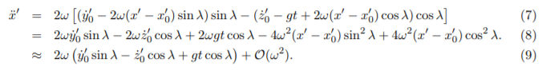

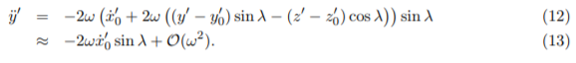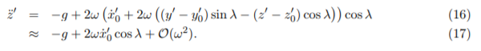

b) Hit the ground at T = 0.4929090120088437 s with vx,vy,vz = [-1.15795794e-02 1.72471836e+02 -7.60721315e+00] m/s and x,y,z = [-3.38905574e-03 1.10704075e+02 0.00000000e+00] m. This is close to the analytic results.

c) Hit the ground at T = 0.49305257944251063 s with vx,vy,vz = [ 1.72450579e+02 1.18230526e-02 -7.60535992e+00] m/s and x,y,z = [1.10728952e+02 3.44770858e-03 0.00000000e+00] m This is close to the analytic results.

d) Hit the ground at T = 4.465755233947599 s with vx,vy,vz = [ 37.92524496 -6.71714322 -37.68892547] m/s and x,y,z = [345.17234913 -61.27719278 0. ] m

I know this converged to a 1 mm precision because I used a very small timestep to check for a good accuracy (0.0001 s) and then ran to make sure these results were within 1 mm of that number.

In the first image below the slope going up is not as steep as the slope going down. This is because both gravity and the gas drag are working against the projectile’s direction of motion. Going down, gas drag is still working against the object, but gravity is now working with it, and thus the slope is steeper. Furthermore, the inertial reference frame does not observe the imaginary force that the non-inertial reference frame would see adding to the acceleration if the object was fired opposite the direction of rotation and subtracting if the object was fired in the direction of rotation.

The second image shows the trajectory in the x’-y’ plane. It appears to be a straight line, which confused me as I thought a projectile in the non-inertial reference frame should appear to curve by some imaginary force. I was expecting a curve, but the straight line suggests that I may be observing something else.

